**Confirmation of Registration for the 15th Annual Rocky Mountain Woodturning Symposium**

To: name

This letter is to inform you that you are registered for the 15th Annual Rocky Mountain Symposium. The doors to the exhibition hall will be open at 1:00 PM on Friday September 13, 2013, for registration. Registration will also be continued on Saturday morning starting at 7:30 AM. The Registration Packets will contain your name tags, the latest schedule of events and other useful 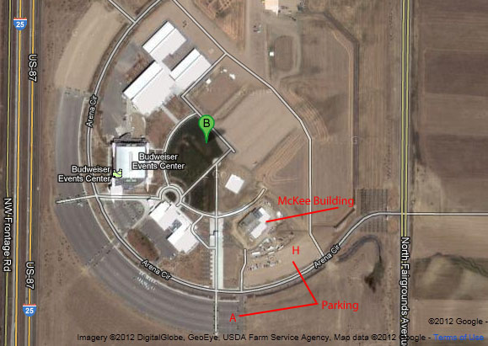information. If you have a guest with you and would like to bring them to the Saturday evening Banquet, extra tickets are available at $30.00 each.

The Trade Show will open at 3:00 PM on Friday and the **first rotations for the Symposium will begin at 4:00 PM**. At 6:00 PM the exhibition hall, the Trade Show and Registration will be closed. All attendees are invited to a **Meet and Greet** at the Loveland Woodcraft store starting at 6:00 PM. Come and visit with the Demonstrators and other attendees. Refreshments will be provided.

The Opening Ceremony will be starting at 8:00 AM Saturday morning.

**Directions to Symposium**  
For those of you outside of the Loveland – Fort Collins area, travel towards Loveland on I25. Take the Crossroads Boulevard exit, Exit 259, travel east and watch for the signs for the Budweiser Events Center. You will be directed to the second stop light where you will turn North on Fairgrounds Avenue. Go to the first Fairgrounds entrance to enter by turning west (towards the mountains). **We will be parking in lots A and H.** The Symposium is being held in the **McKee Building** across the street directly to the North of the parking area (see map).. **Note** that the top of the map is **north** and you will be entering the Fairgrounds from the entrance at the right side of the map.

**Instant Gallery**  
We have a large area set aside this year for the **Instant Gallery** for you to bring up to three of your best works to share with the attendees and the public. The **Instant Gallery** is open to public viewing at no charge. On Sunday morning there will be a critique of selected pieces. This is a great opportunity to learn from each other.

**Hands-on Learning Center**Again this year, the Hands-on Learning Center is open to all **on a first come basis**. It has been redisigned to enhance the learning experience of those participating in it. **Several of our top demonstrators** will be conducting the Hands-on rotations. Each hour and a half session will be project oriented. There will be eight mini-lathes set up for usage by those participating. An Instructor will guide those present through the process of making a small project that they may take with them. The projects are to be announced.

**Banquet and Auction**

Vessel – a hollow or concave utensil, as a cup, bowl, pitcher, or vase, used for holding liquids or other contents.

The Symposium is requesting donations of vessels to be used as center pieces at the tables during the banquet. These vessels will be auctioned off later in the evening as part of the fund rasing for the **RMWT Educational Opportunity Grants**. The vessels should have the artists name on the bottom and fit within a 6 inch cube. The Symposium Committee is planning on a surprise recognition for one or more of the vessel donations. This is an opportunity for exercising creativity and inventiveness, and no, the vessels are not required to hold a liquid without leaking.

Saturday evening following the banquet, there will be an **Auction** of items donated to the Symposium. The Auction will contain both a live auction and a silent auction. The items usually range from wood and tools to fine art turnings. The proceeds from the Auction are **used to fund the Educational Opportunity Grant (EOG)program of the Rocky Mountain Woodturners**. The EOG is used to promote woodturning and woodturning education in the community. In the past we have awarded several grants to local schools and Woodturners. At the Banquet, several receipitants will be telling us how they utilized their grants to advance woodturning skills of their students or themselves. These will be very interesting presentations. Attendees to the Symposium are welcome to bring items to donate to the auction.

For the latest information on the scheduled Rotations (demonstrations), go to the Symposium web site at [www.rmwoodturningsymposium.com](http://www.rmwoodturningsymposium.com)

**Lodging:** For those of you that do not have accommodations yet, the above web site has a link to the local hotels and motels several of them have blocks of rooms reserved for the Symposium. There are several new ones located adjacent to the Events Center. For those of you with RVs, the web site lists several of the local RV Parks which have full hookups and shade trees.

We will do our best to accommodate anyone with disabilities. If you will be needing special assistance contact:

John I. Giem  
Symposium Registrar  
[jgiem@comcast.net](mailto:jgiem@comcast.net)  
970 223-0844, H; 970 227-6618, Mobile

Or

Allen Jensen  
Symposium Coordinator  
[rajconst@aol.com](mailto:rajconst@aol.com)  
970 663-1868